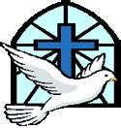

Confirmation Certificate - Saint Name

Student’s Name: _______________________________________________

Chosen Saint’s Name: __________________________________________

Student’s name as you would like it to appear on the certificate:

First Saint Name Last Name

- Please print legibly

- Form is due at our last Confirmation Class on May 7, 2023. Your child will make their confirmation in the fall of 2024 if we do not have your form by May 7.

